sudo apt install qemu-kvm libvirt-daemon-system libvirt-clients bridge-utils -y

sudo kvm-ok

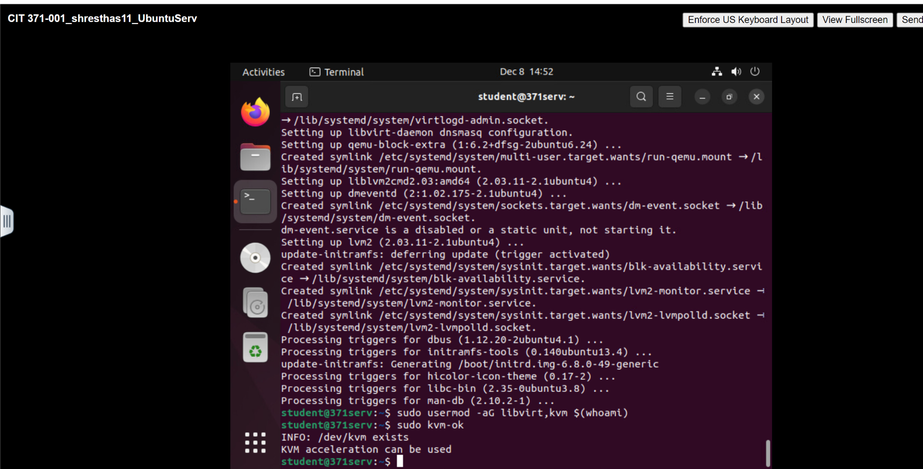

sudo mv Downloads/TinyCore-current.iso /var/lib/libvirt/images//lib/libvirt/images/
sudo apt install virt-manager -y
Virt-manager
sudo systemctl restart libvirtd
sudo usermod -aG libvirt,kvm $(whoami)
newgrp libvirt

https://www.reddit.com/r/pop_os/comments/zzyfrh/dock_running_virtmanager_error_qemu_kvm_not/

